Transport Layer
The network layer is responsible for source-to-destination delivery of individual packets. The transport layer is responsible for process-to-process delivery of the entire message. A process is an application program running on a host. Computers often run several programs at the same time. For this reason, source to-destination delivery means delivery not only from one computer to the next but also from a specific process on one computer to a specific process on the other. The transport layer header must therefore include a type of address called port number or port address. The port numbers are 16-bit integers between 0 and 65,535.
. A process on the local host, called a client, needs services from a process usually on the remote host, called a server. Both processes (client and server) have the same name. For example, to get the day and time from a remote machine, we need a Daytime client process running on the local host and a Daytime server process running on a remote machine.
The client program defines itself with a port number, chosen randomly by the transport layer software running on the client host. This is the ephemeral port number.The server process must also define itself with a port number. This port number, however, cannot be chosen randomly. If the computer at the server site runs a server process and assigns a random number as the port number, the process at the client site that wants to access that server and use its services will not know the port number. The Internet has decided to use universal port numbers for servers; these are called well-known port numbers. Every client process knows the well-known port number of the corresponding server process. For example, while the Daytime client process can use an ephemeral (temporary) port number 52,000 to identify itself, the Daytime server process must use the well-known (permanent) port number 13.
Three Protocols
The Internet model has three protocols at the transport layer: UDP, TCP, and SCTP. First we discuss UDP, which is the simplest of the three. We see how we can use this very simple transport layer protocol that lacks some of the features of the other two. We then discuss TCP, a complex transport layer protocol. SCTP is the new transport layer protocol that is designed for multihomed, multistream applications such as multimedia.

USER DATAGRAM PROTOCOL (UDP)
The User Datagram Protocol (UDP) is called a connectionless, unreliable transport protocol. It does not add anything to the services of IP except to provide process-to-process communication instead of host-to-host communication. Also, it performs very limited error checking.
UDP is a very simple protocol using a minimum of overhead. If a process wants to send a small message and does not care much about reliability, it can use UDP. Sending a small message by using UDP takes much less interaction between the sender and receiver than using TCP or SCTP.
Well-Known Ports for UDP
Table shows some well-known port numbers used by UDP. Some port numbers can be used by both UDP and TCP
Well-known ports used with UDP
Port | Protocol | Description
7 | Echo | Echoes a received datagram back to the sender
9 | Discard | Discards any datagram that is received
11 | Users | Active users
13 | Daytime | Returns the date and the time
17 | Quote | Returns a quote of the day
19 | Chargen | Returns a string of characters
53 | Nameserver | Domain Name Service
67 | BOOTPs | Server port to download bootstrap information
68 | BOOTPc | Client port to download bootstrap information
69 | TFTP | Trivial File Transfer Protocol
111 | RPC | Remote Procedure Call
123 | NTP | Network Time Protocol
161 | SNMP | Simple Network Management Protocol
162 | SNMP | Simple Network Management Protocol (trap)

User Datagram: UDP packets, called user datagrams, have a fixed-size header of 8 bytes.
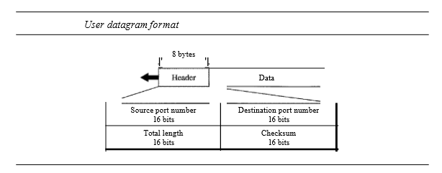
The fields are as follows:
- Source port number. This is the port number used by the process running on the source host. It is 16 bits long, which means that the port number can range from 0 to 65,535.
- Destination port number. This is the port number used by the process running on the destination host. It is also 16 bits long.
- Length. This is a 16-bit field that defines the total length of the user datagram, header plus data.
- Checksum. This field is used to detect errors over the entire user datagram (header plus data).

UDP Operation
Connectionless Services: UDP provides a connectionless service. This means that each user datagram sent by UDP is an independent datagram. There is no relationship between the different user datagrams even if they are coming from the same source process and going to the same destination program. The user datagrams are not numbered. Also, there is no connection establishment and no connection termination. This means that each user datagram can travel on a different path Only those processes sending short messages should use UDP.

No Flow and Error Control: UDP is a very simple, unreliable transport protocol. There is no flow control. The receiver may overflow with incoming messages. There is no error control mechanism in UDP except for the checksum. This means that the sender does not know if a message has been lost or duplicated. When the receiver detects an error through the checksum, the user datagram is silently discarded.

Encapsulation and Decapsulation: To send a message from one process to another, the UDP protocol encapsulates and decapsulates messages in an IP datagram.

Queuing: In UDP, queues are associated with ports. Incoming and outgoing ports are different in UDP, so two queues are used to handle these operations.
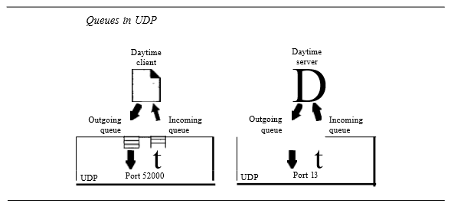
At the client site, when a process starts, it requests a port number from the operating system. The queues opened by the client are, in most cases, identified by ephemeral port numbers. The queues function as long as the process is running. When the process terminates, the queues are destroyed.
The client process can send messages to the outgoing queue by using the source port number specified in the request. When a message arrives for a client, UDP checks to see if an incoming queue has been created for the port number specified in the destination port number field of the user datagram. If there is such a queue, UDP sends the received user datagram to the end of the queue. If there is no such queue, UDP discards the user datagram and send a port unreachable message to the server.
At the server site, the mechanism of creating queues is different. In its simplest form, a server asks for incoming and outgoing queues, using its well-known port, when it starts running. The queues remain open as long as the server is running. When a message arrives for a server, UDP checks to see if an incoming queue has been created for the port number specified in the destination port number field of the user datagram. If there is such a queue, UDP sends the received user datagram to the end of the queue. If there is no such queue, UDP discards the user datagram and send a port unreachable message to the client When a server wants to respond to a client, it sends messages to the outgoing queue, using the source port number specified in the request from the client .

Use of UDP
- UDP is suitable for a process that requires simple request-response communication with little concern for flow and error control. It is not usually used for a process such as FTP that needs to send bulk data.
- UDP is suitable for a process with internal flow and error control mechanisms. For example, the Trivial File Transfer Protocol (TFTP) process includes flow and error control. It can easily use UDP.
- UDP is a suitable transport protocol for multicasting. Multicasting capability is embedded in the UDP software but not in the TCP software.
- UDP is used for management processes such as SNMP.
- UDP is used for some route updating protocols such as Routing Information Protocol (RIP)

